**ECEN 452: Ultra High Frequency Techniques**

**Lab 1: Laboratory Best Practices**

1. Python installation and matplotlib demonstration

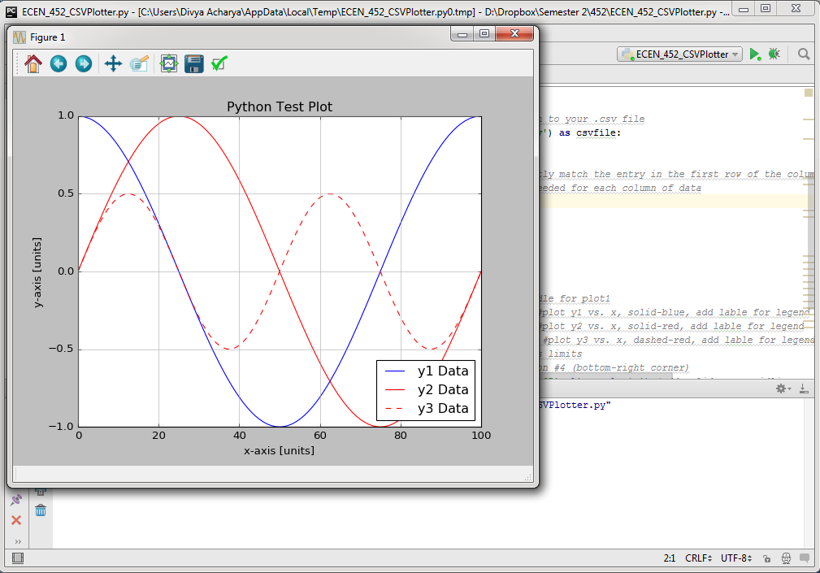

1. Creation of GitHub Account

ID: DivyaNAcharya

1. Familiarize with HFSS and Zolver
2. Calculation of two-port S and ABCD matrices for series impedance Z=10+25j Ω with a characteristic impedance Z0=50 Ω

Solution attached in images S1, S2 S3

1. Shift of reference plane after connection of transmission lines(Z0=50 Ω)of length 0.8λ and 0.25λ

Solution attached in image S4

1. Plots of S11(dB) and S21(dB) comparing Analytical, Z0lver and HFSS solutions:
2. 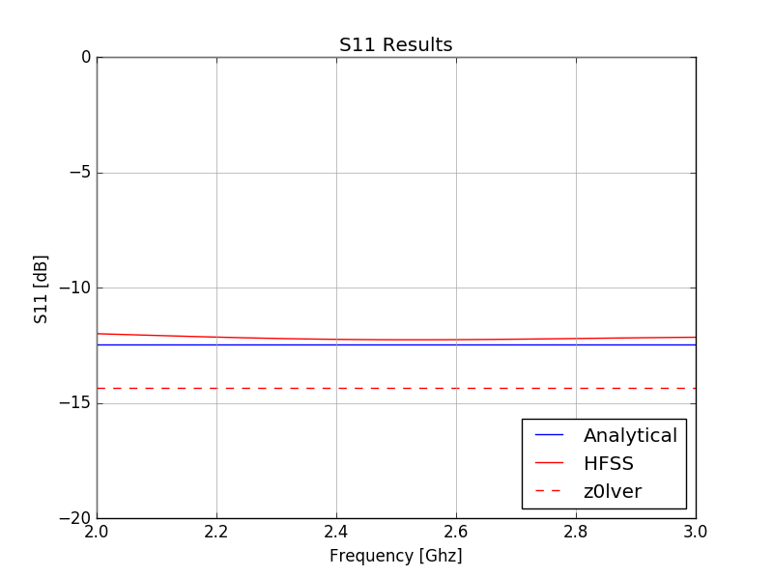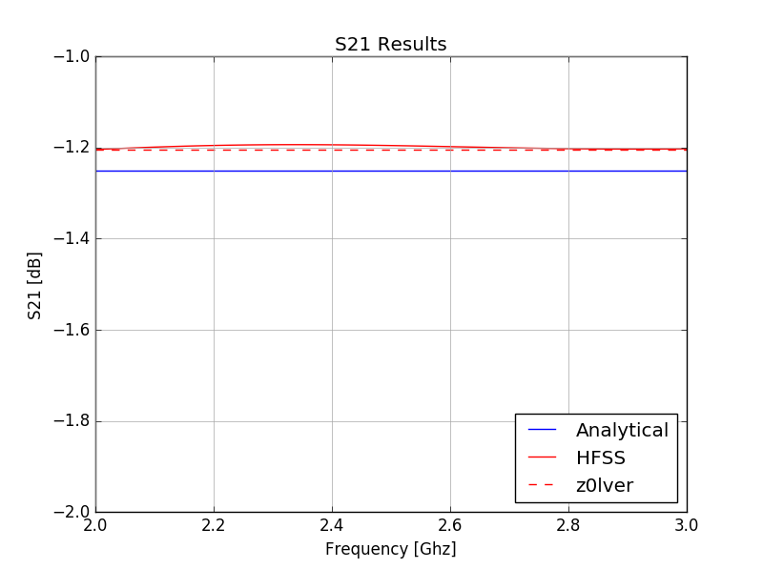
3. Substrate Properties:

|  |  |  |  |  |
| --- | --- | --- | --- | --- |
|  | **FR4** | **Duroid 5880** | **Duroid 6006** | **Duroid 6010.2** |
| **εr** | 4.8 | 2.2 | 6.45 | 10.7 |
| Tan δ | 0.017 | 0.004 | 0.0027 | 0.0023 |

1. ‘Y’ Indicates that the connector types can be mated:

|  |  |  |  |  |  |  |
| --- | --- | --- | --- | --- | --- | --- |
|  | **Type N** | **SMA** | **3.5mm** | **2.92mm** | **2.4mm** | **1.85mm** |
| **Type N** | Y |  |  |  |  |  |
| **SMA** |  | Y | Y | Y |  |  |
| **3.5mm** |  | Y | Y | Y |  |  |
| **2.92mm** |  | Y | Y | Y |  |  |
| **2.4mm** |  |  |  |  | Y | Y |
| **1.85mm** |  |  |  |  | Y | Y |